## horizontal line

MLP Intuition(class7)

10.01.2025

**─**

# The Problem

This cannot be achieved directly . First 2 linear perceptrons are constructed then they are superimposed over each other to get a more precise region . After smoothening a curve is achieved that is classified correctly .

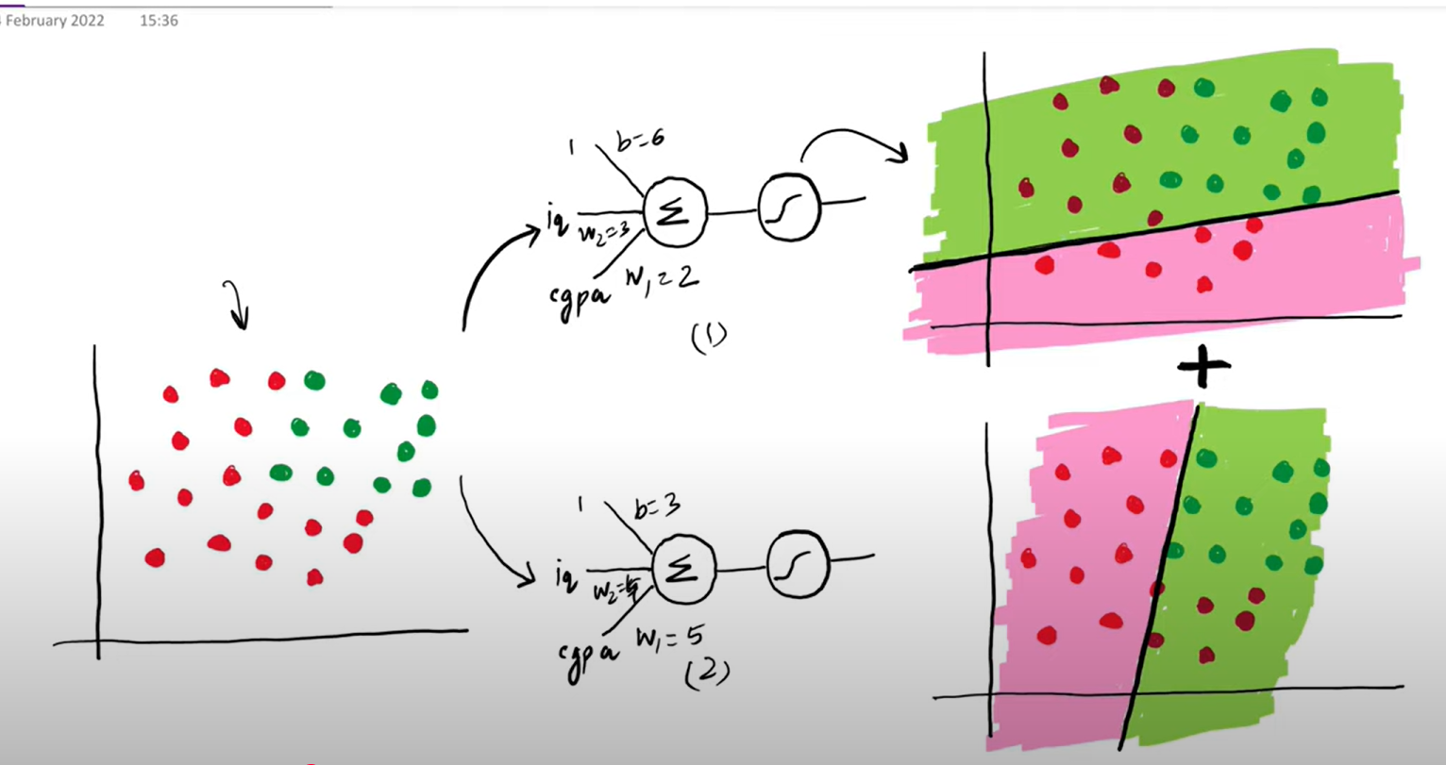

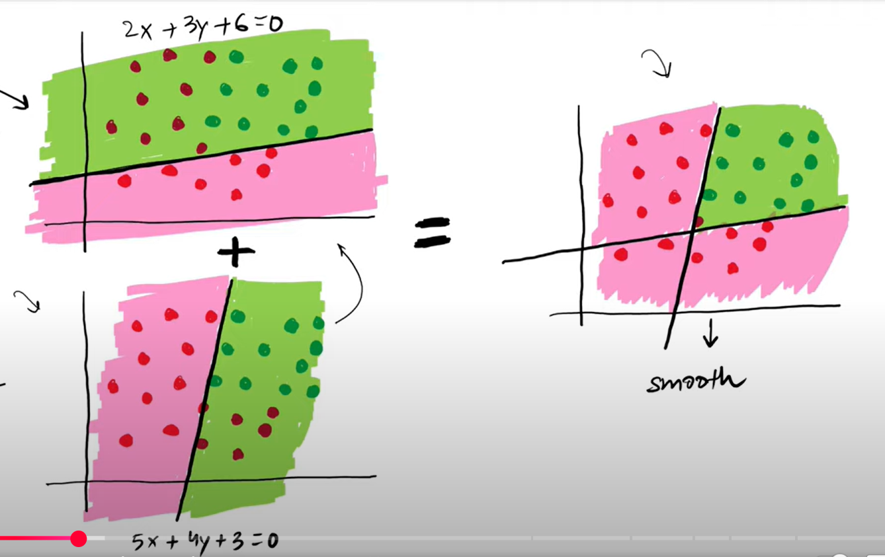

Let suppose the Perceptron P1 has an equation of line 2x+3y+6 = 0 and Perceptron p2 has 5x+4y+3 = 0.

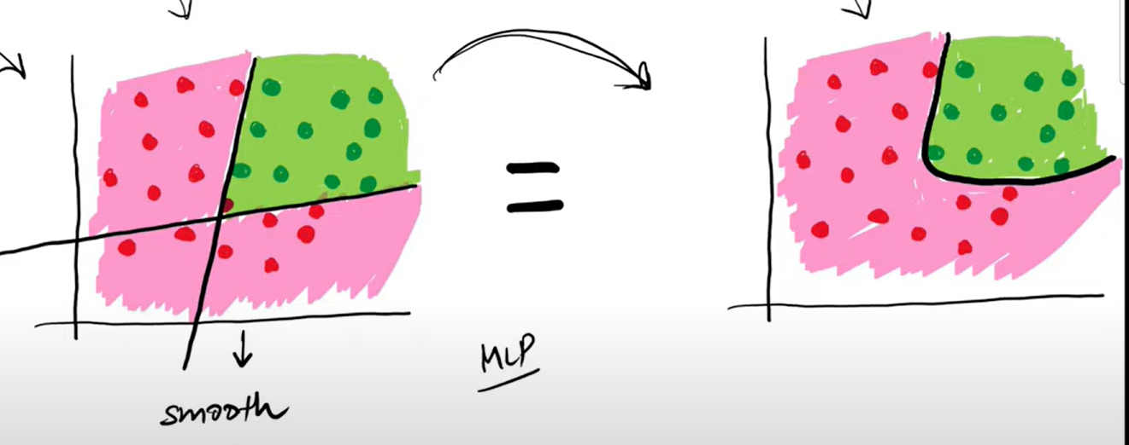

# The Mathematical Intuition

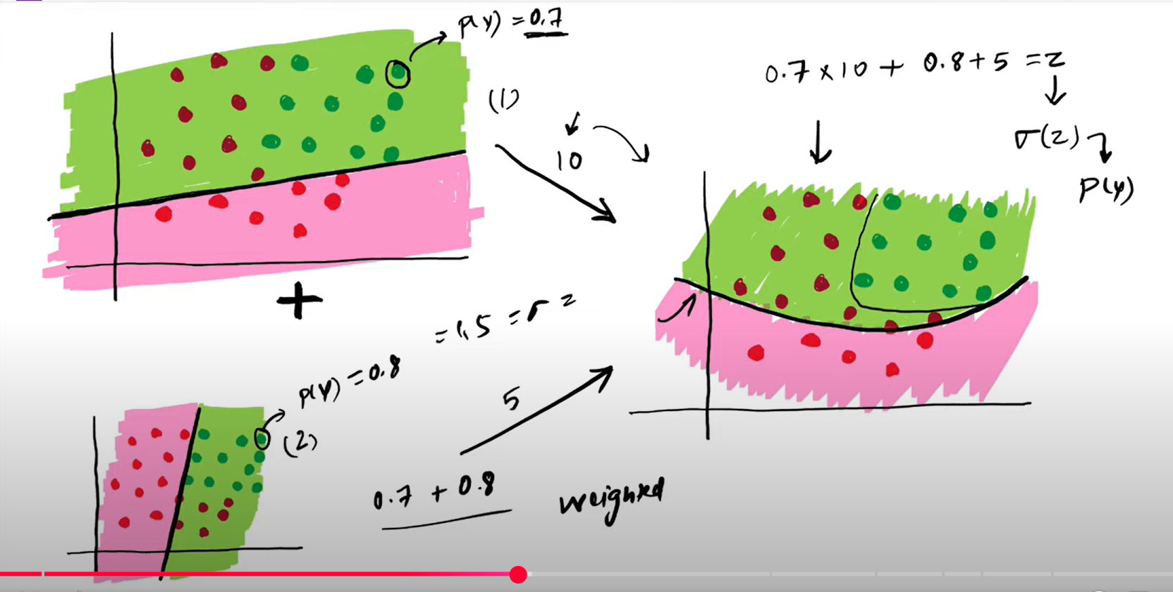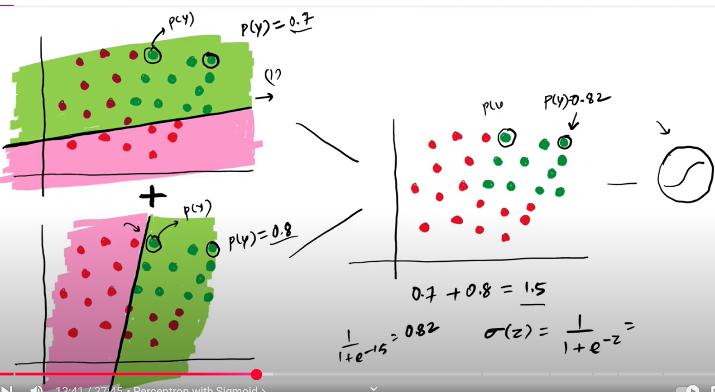

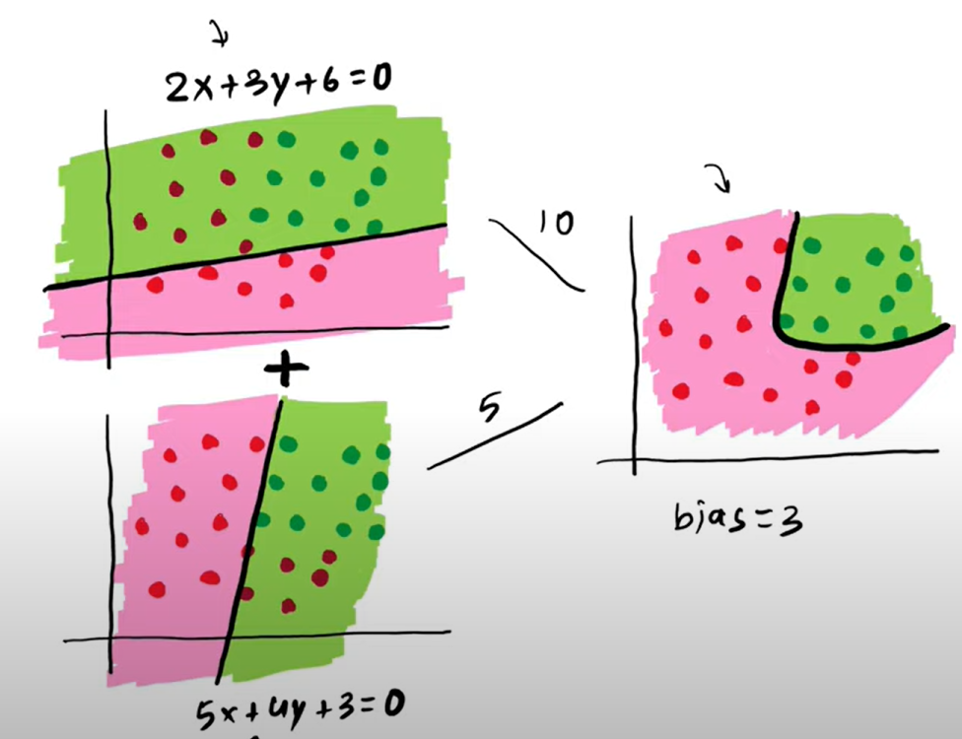

**It is basically a linear combination of perceptrons.**



# 

# How to change the Neural Network Architecture ?

## Adding nodes in hidden layer

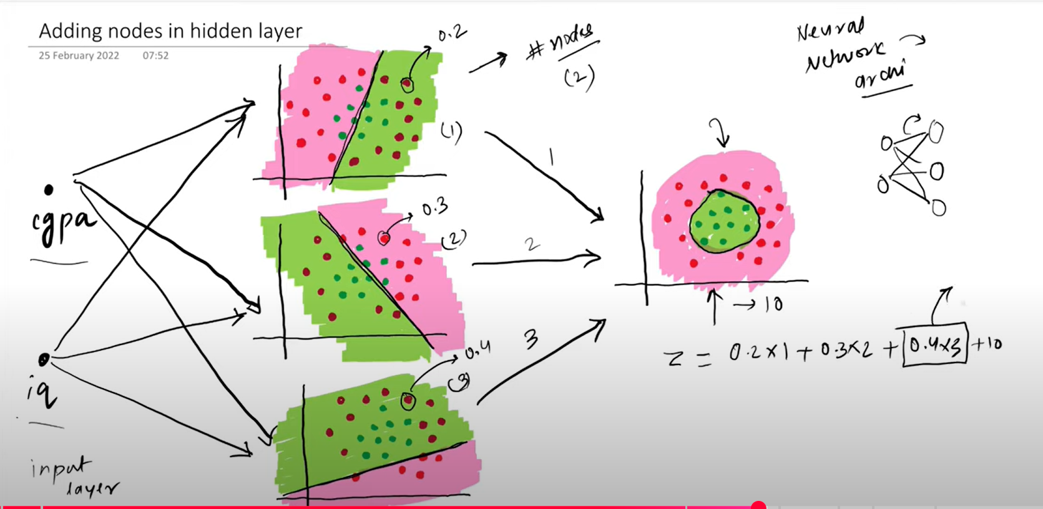

## Adding nodes in input layer

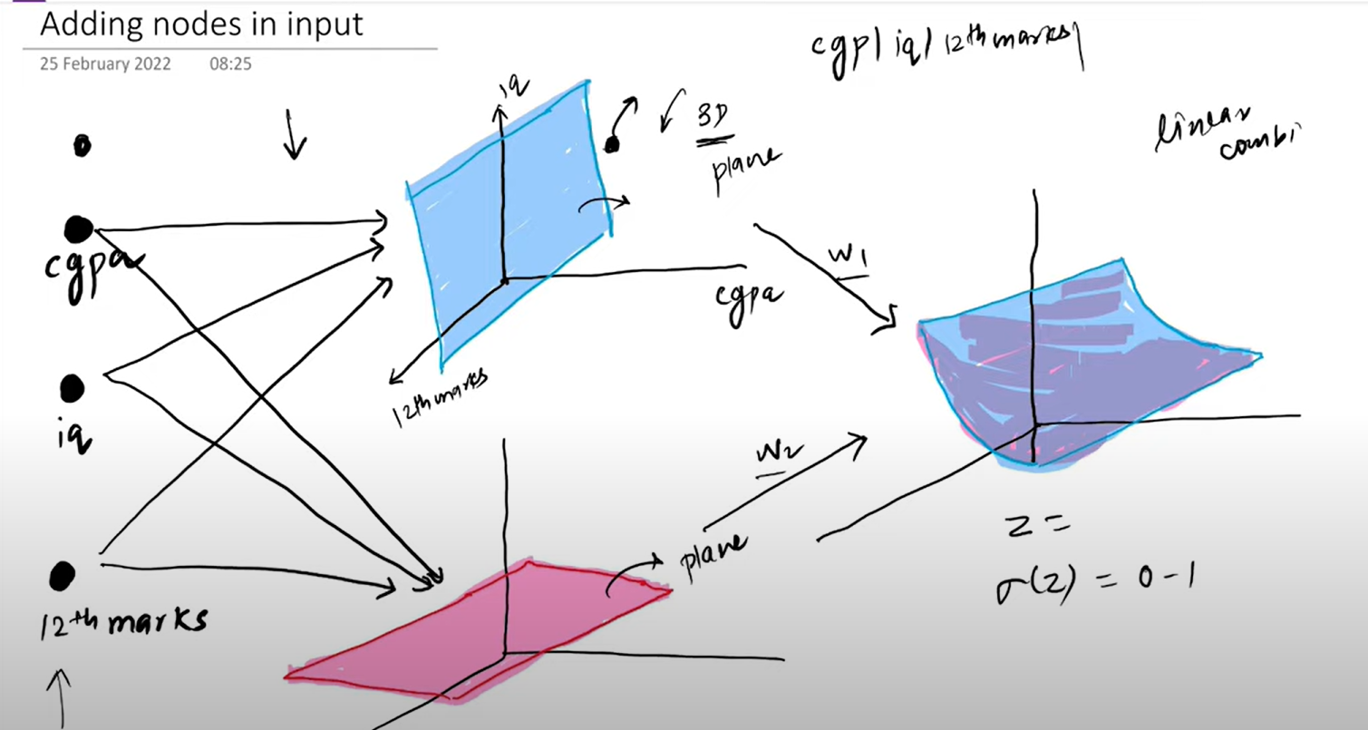

## Adding nodes in output layer

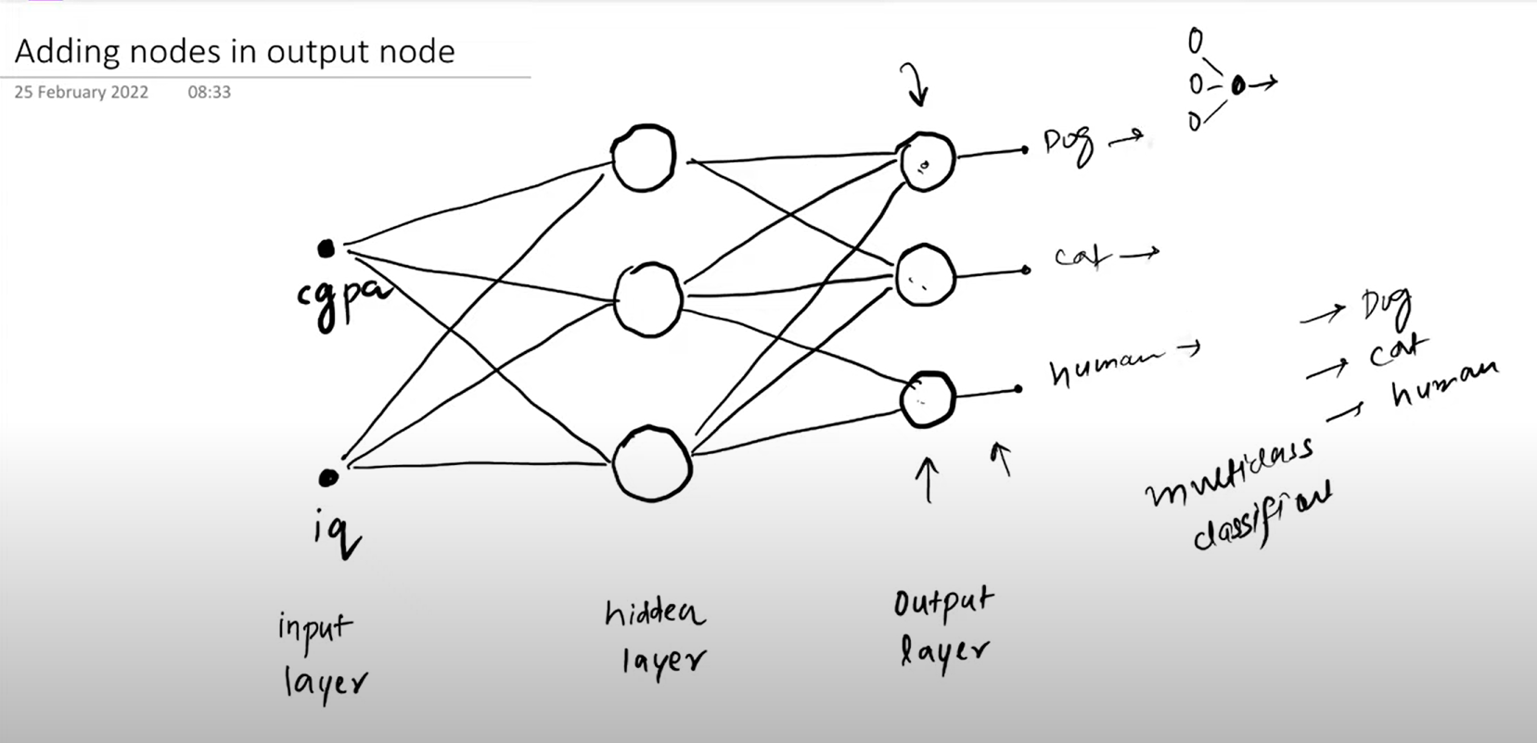

## Adding hidden layers (Deep neural network)

## 

That is why it is called UFA (Universal Function Approximator) , that is any function can be solved given some time for training .